Task 1-4

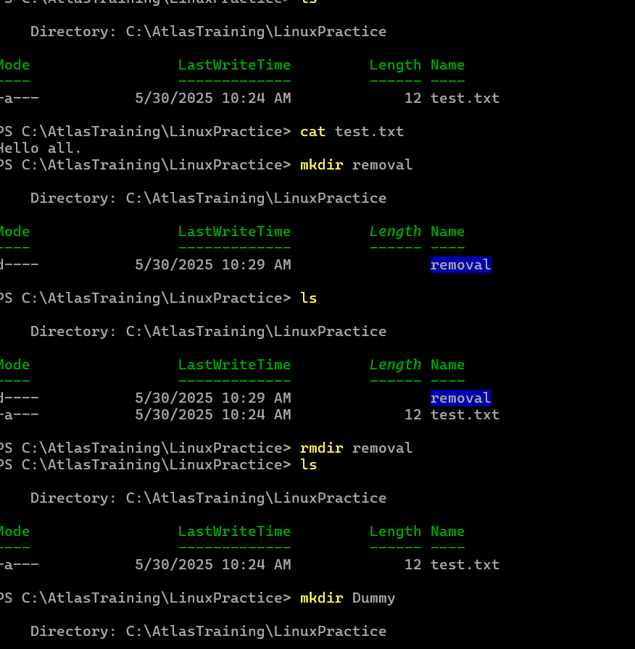

Task 4-6

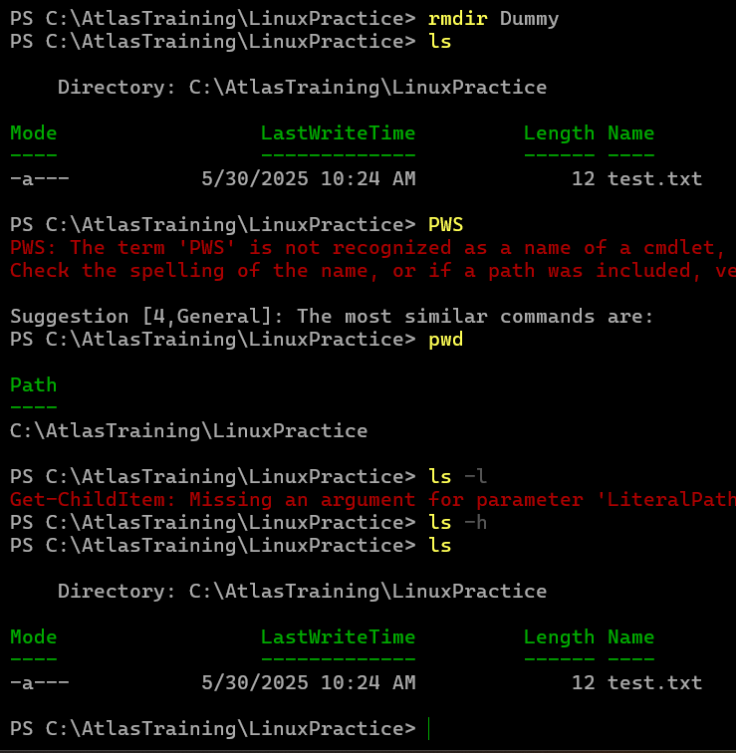

Task 7

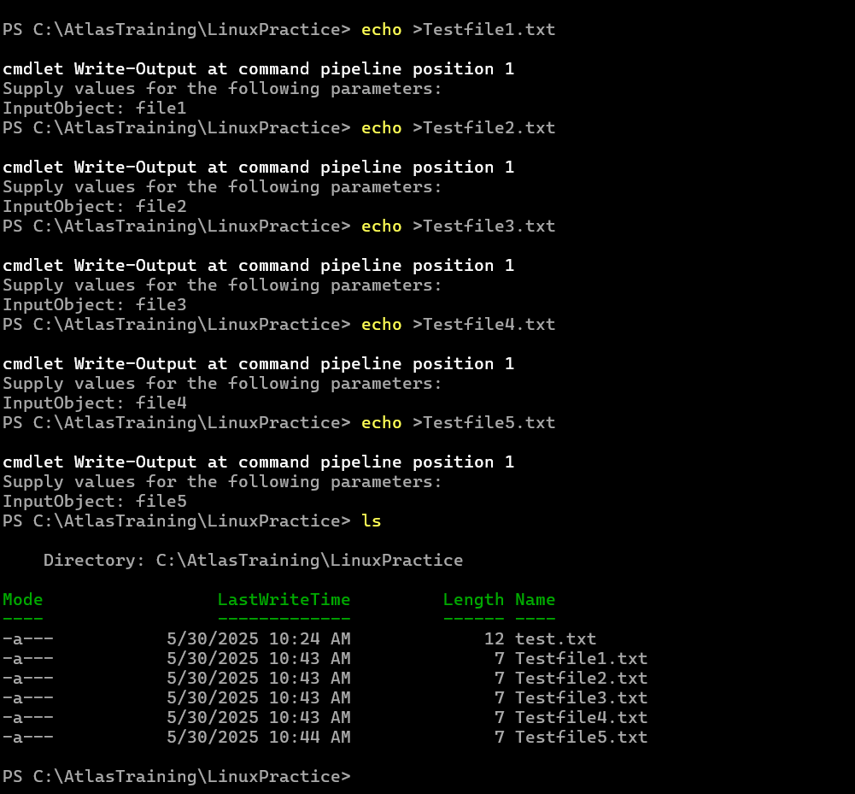

Task 8-9

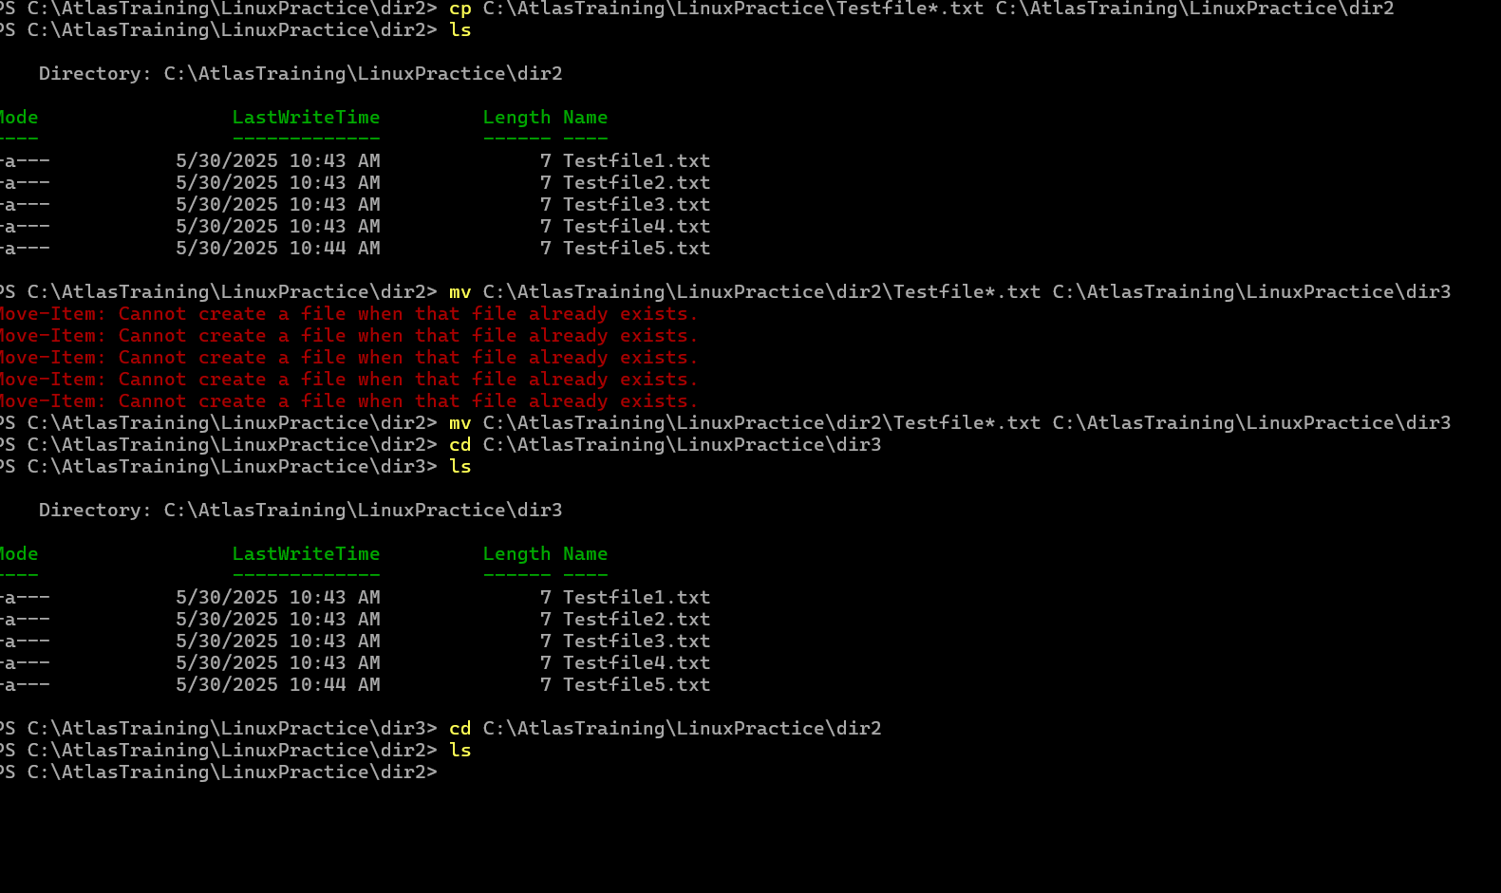

Task 10

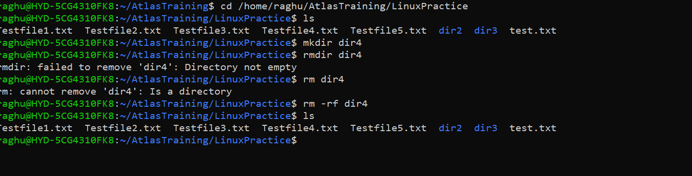

Task 11

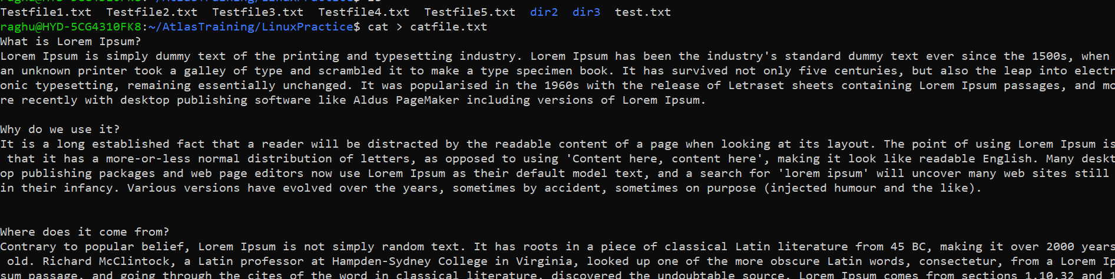

Task 12

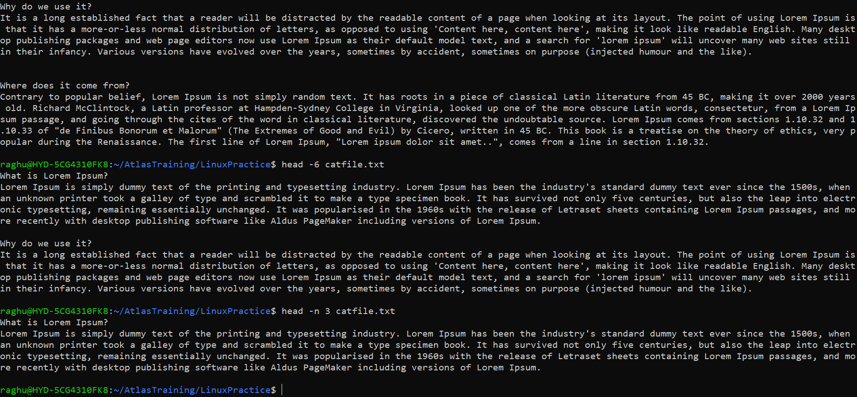

Task 13

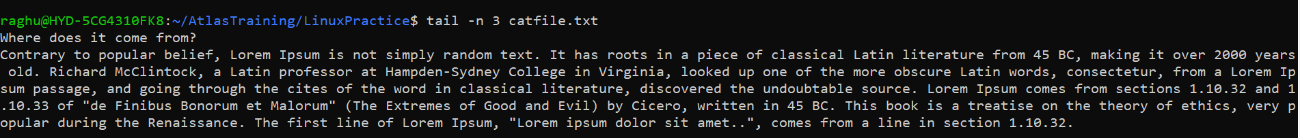

Task 14

Less catfile.txt

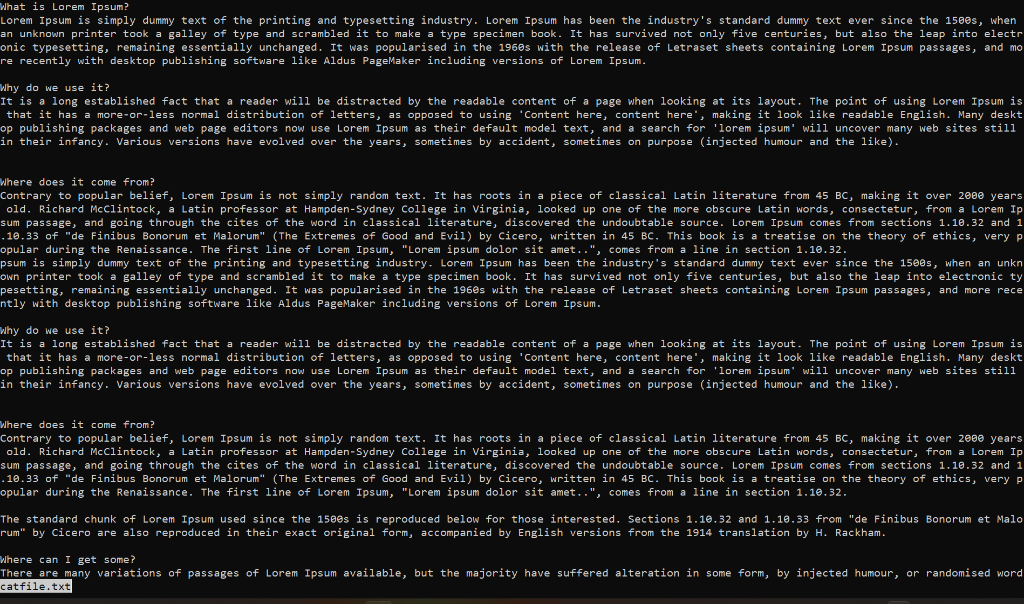

Task 15

More can be used to scroll page by page using spacebar or line by line using enter key.

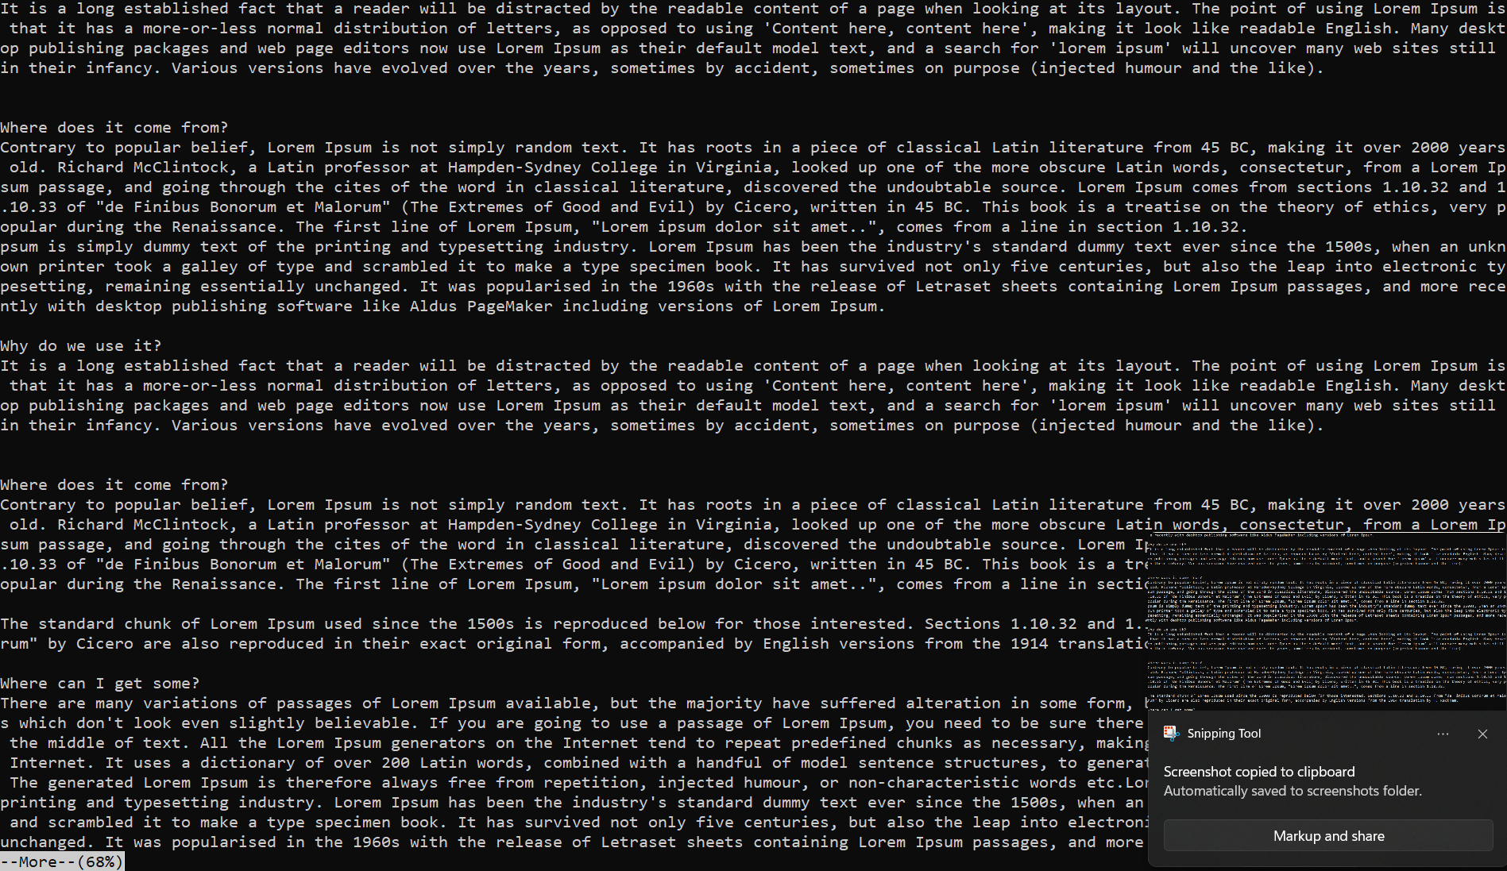



Task 16

Difference b/w echo and echo -e

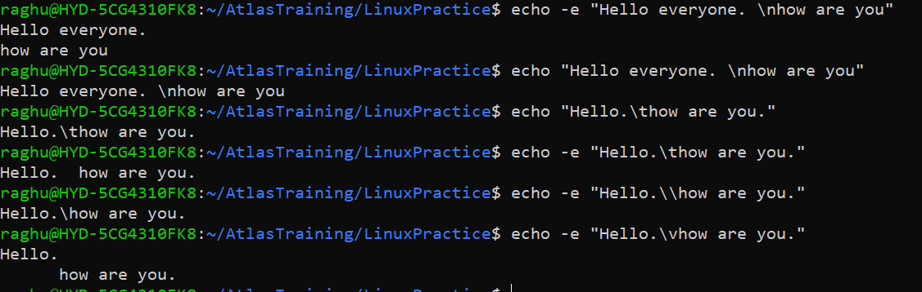

Task 17

Ls lists all files, ls-l lists files with details.

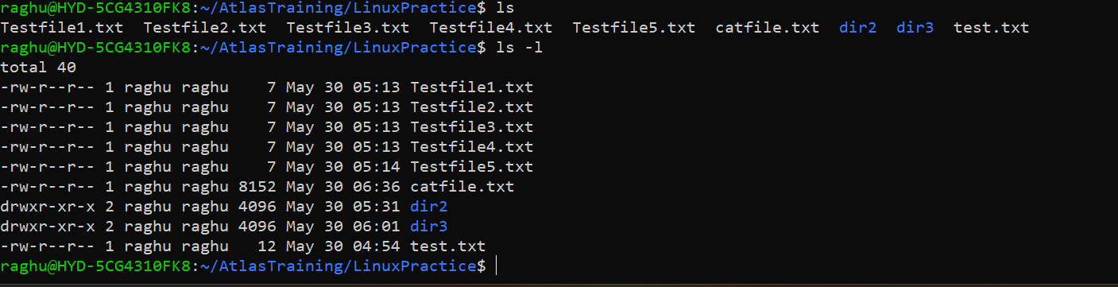

Task 18

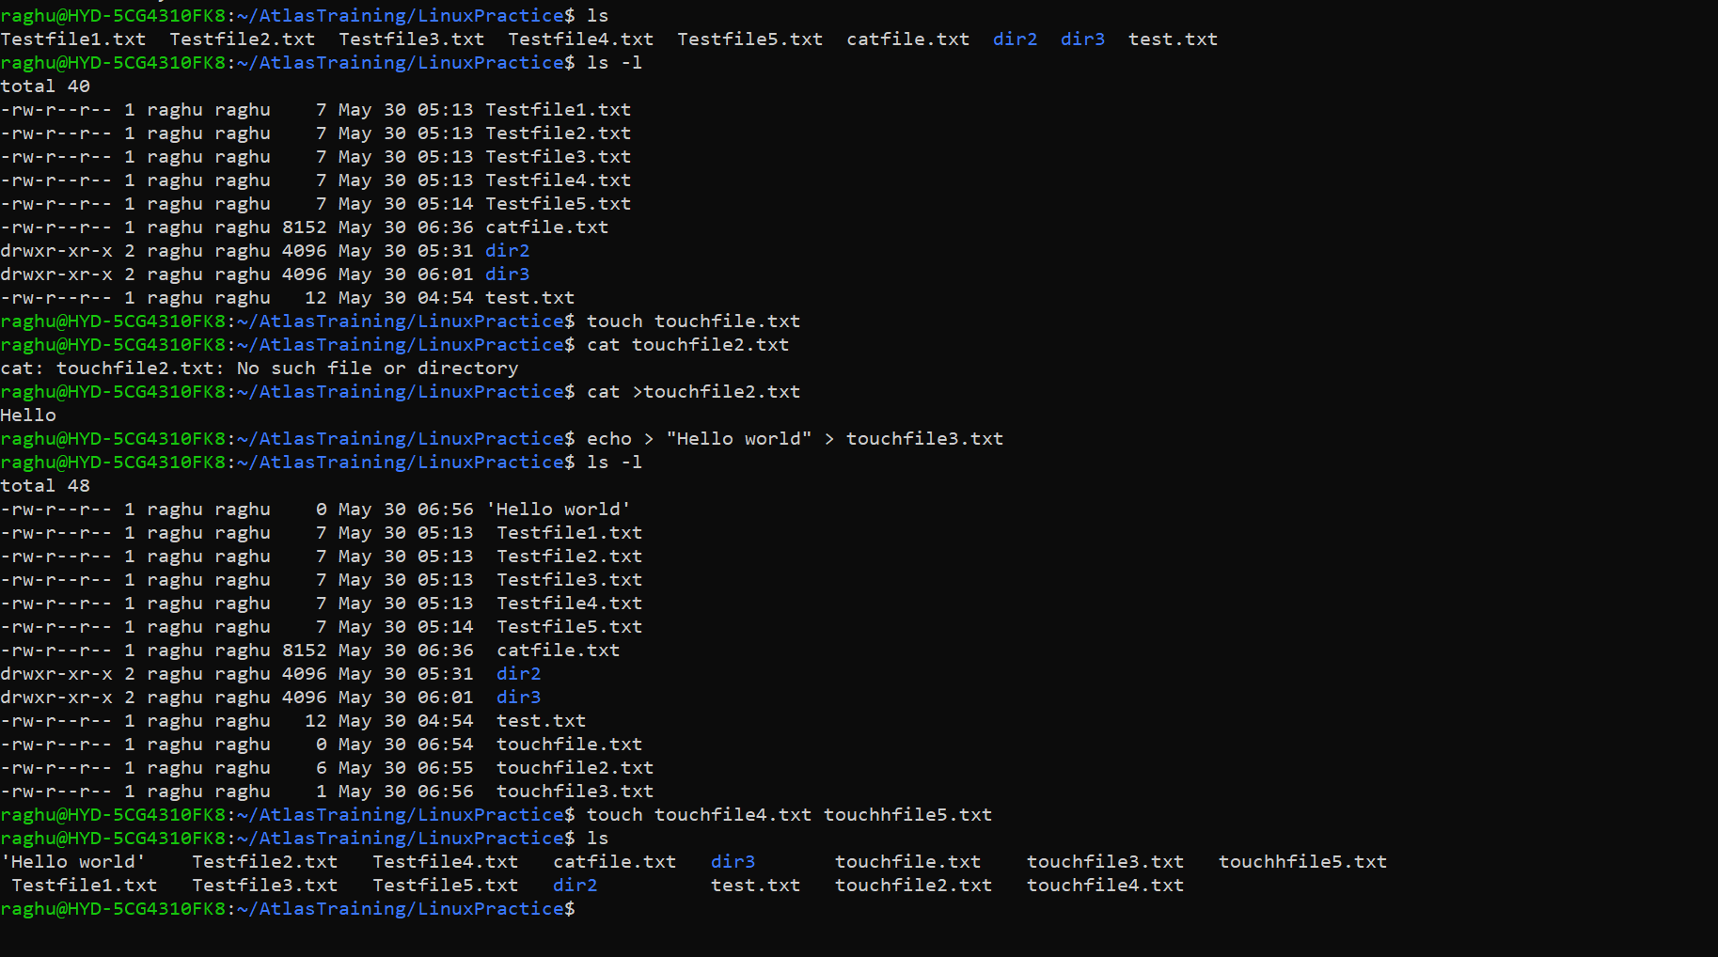

Task 19

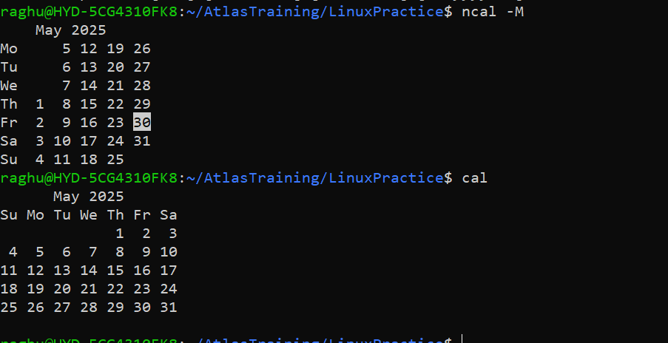

Task 20

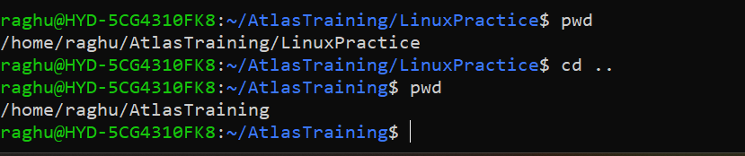

Task 21-23

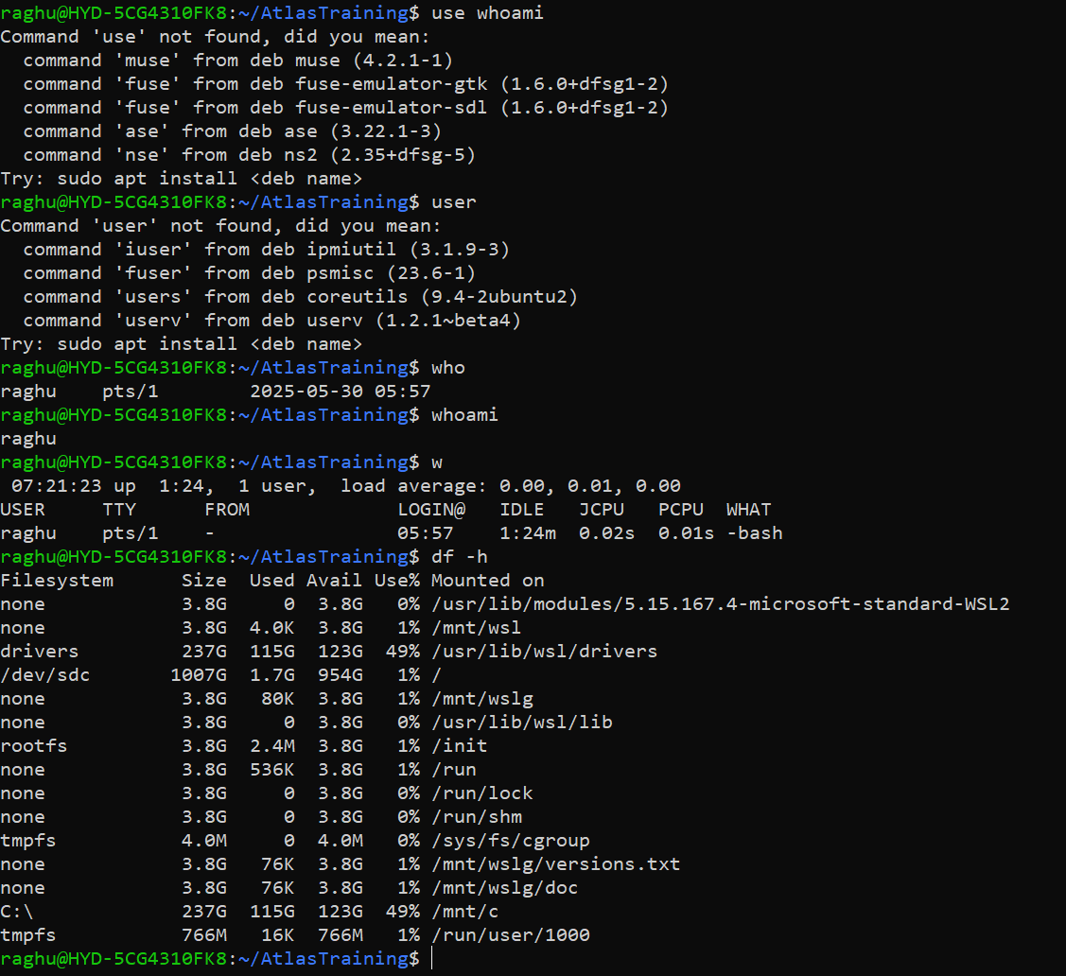

Task 24

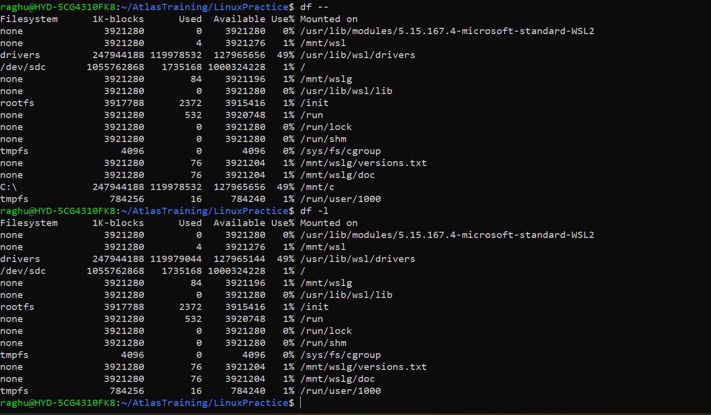

Task 25-26

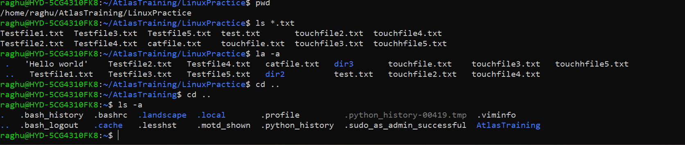

Task 27

. specifies the current directory. In usage, cd . keeps us in the same directory. Its also used to specify a directory when give environmental path variables.

.. is used to refer to the parent directory or the directory just above the current directory.

Task 28

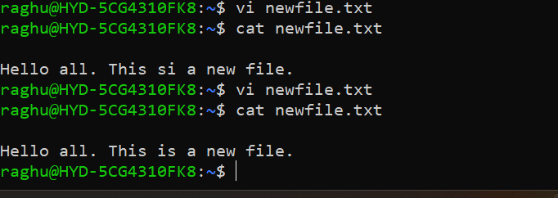

Task 29

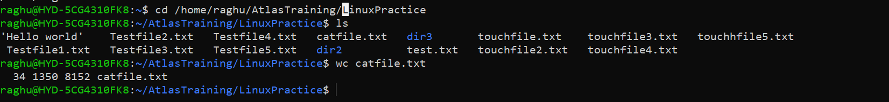

Task 30

cat -b command will display all the non-empty lines from one or more files and also numbers them in order starting from 1.

Task 31

wc can be used with multiple files. It’ll show details of individual files and also a total at the last row.

Task 32

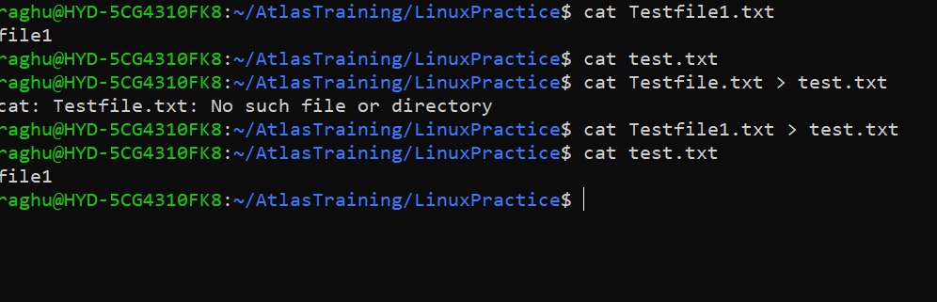

Task 33

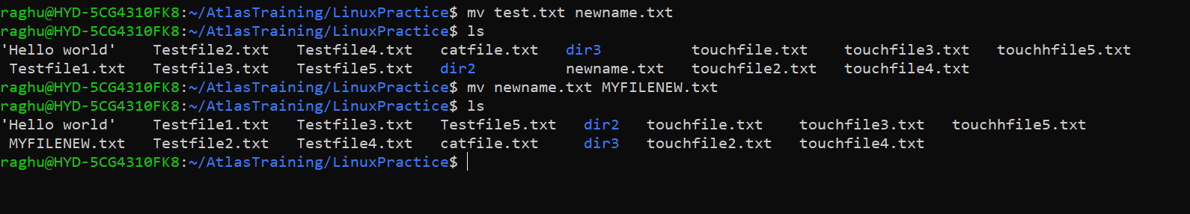

Task 34.

Yes. Demonstrated in the snip below.

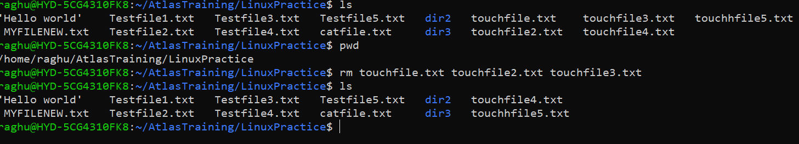

Task 35.

Cd / returns you to root directory.

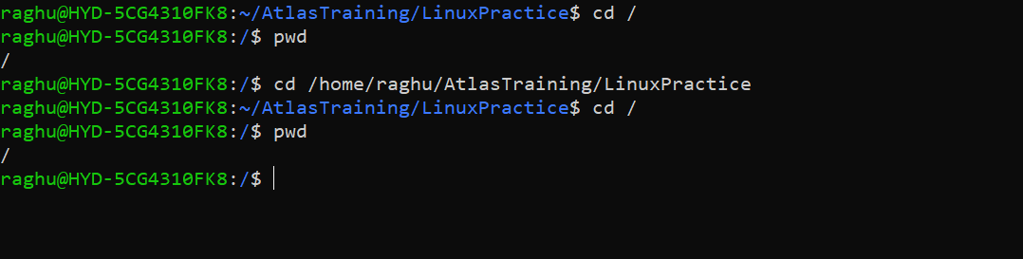

Task 36

Cd /home takes us to home directory.

Task 37

